*M.E.H*

*Time of the activity: 5:00pm Date of the activity: Mon 7th of October.*

*Usability testing*

Name of the participant: Nicola. G

**Facilitatory help notes:** Give them the task, but do not tell them how to complete it. Ask them to talk out loud while they do it. Did they complete the task? Did they need help? Explain where they needed help? How long did it take for them to complete that task?, What was the error rate (0 – no errors, 5 a lot of errors), this allows us to communicate through quantitative data. Explain why and where those errors occurred. Similar process to success rate (0 – no success – 5 great success) – success can be measured on errors, but more so on confusion and how easy it was. User satisfaction (0 poor – 5 great) comment on when, where, why and how. General comments about the task, more so about body language, and think aloud comments. After testing is complete gather themes and insights, and personal solutions you or the individual believes would be appropriate.

Application:

Task: So you have the application – set up the Bluetooth from the visual representation. (Connect to the wearable)

|  |  |
| --- | --- |
| Could they complete the task? | YES / NO (circle)  Comment: |
| Did they need help? | YES / NO (circle)  Comment: |
| Time | 10 seconds. |
| Error rate | ( 0 – 1 – 2 – 3 – 4 – 5) |
| Error comments | User made no errors. |
| Success rate | ( 0 – 1 – 2 – 3 – 4 – 5) |
| Success comments | Use was successful. |
| User satisfaction | ( 0 – 1 – 2 – 3 – 4 – 5)  Comments:  The user believed it was very easy, to set up Bluetooth, it was self explanatory. |
| General comments | “At least you didn't have to go into settings and learning, You know, settings on your device. So in that sense, it's definitely a lot easier to have that as part of the app” |
| Common themes and insights | Correlation from usability and satisfaction.  Good information design mades it more usable, users prefer stream lines approaches, with information clearly visible. |
| Suggested solutions | NIL |

Task: Using the visual representation, set up an account.

|  |  |
| --- | --- |
| Could they complete the task? | YES / NO (circle)  Comment: |
| Did they need help? | YES / NO (circle)  Comment: |
| Time | 15 seconds |
| Error rate | ( 0 – 1 – 2 – 3 – 4 – 5) |
| Error comments | The plateforms, needed explaining, had to show were to click on the mock up |
| Success rate | ( 0 – 1 – 2 – 3 – 4 – 5) |
| Success comments | Once the errors were explained, the application ran well. |
| User satisfaction | ( 0 – 1 – 2 – 3 – 4 – 5)  Comments:  User enjoyed the process, “easy to use”, makes sense but needs to be written and represented better. – “what do the plateforms mean?” |
| General comments | “Plate form part is confusing, but I suppose when your using the actual application that will change, |
| Common themes and insights | Clear naming is important to not confuse the user. Plate form wording was a mock of style issue, but it confused the user when the language didn’t match real world standards. |
| Suggested solutions | Don’t use the word plateform – represent through iconography, and just state the plateform, e.g sign in through facebook. |

Task: Using the visual representation – transfer money to the wearable.

|  |  |
| --- | --- |
| Could they complete the task? | YES / NO (circle)  Comment: |
| Did they need help? | YES / NO (circle)  Comment: |
| Time | 30 secs. |
| Error rate | ( 0 – 1 – 2 – 3 – 4 – 5) |
| Error comments | User automatically wanted to go to ‘activity’ to transfer money, User believed “top up com-it” was a |
| Success rate | ( 0 – 1 – 2 – 3 – 4 – 5) |
| Success comments | Straight to the point, easy to understand. |
| User satisfaction | ( 0 – 1 – 2 – 3 – 4 – 5)  Comments:  It’s easy to use, satisfying because of that. |
| General comments | It’s up front about what it’s about – straight to the point and straight into it.  She believed there should be terms and conditions, specifically privacy ones.  “Any application that hold bank details requires more trust – and more problems if that trust is broken” |
| Common themes and insights | Application is easy to use do the lack of information.  Terms and conditions increase privacy. |
| Suggested solutions | Encrypted bank account details – extra privacy.  Terms and conditions. – disclaimers about not holding bank account details – for extra peace and security. |

Task: From the visual representation, was is the activity on the Com-it wearable.

|  |  |
| --- | --- |
| Could they complete the task? | YES / NO (circle)  Comment: |
| Did they need help? | YES / NO (circle)  Comment: |
| Time | 5 seconds |
| Error rate | ( 0 – 1 – 2 – 3 – 4 – 5) |
| Error comments | No errors – but believed it was confusing, specifically the use of “time” and “location” before the activity page, which had the same data. |
| Success rate | ( 0 – 1 – 2 – 3 – 4 – 5) |
| Success comments | User was able to clearly describe how they completed the process. |
| User satisfaction | ( 0 – 1 – 2 – 3 – 4 – 5)  Comments:  User enjoyed being able to look at the limit and being able to look at what the watch was doing.  The activities features were slightly confusing. She believed it was also a bit invasive, knowing the GPS and the wearable is tracking the loved one. |
| General comments | Clear and easy to understand the visual – she likes the graph, she believes it assist in creating more awareness about money lost, which is good, in the sense it can be used to alert the user, and stop them from going too crazy with their money  “No, I think this is great. Because I will tell you, if you've got a joint bank account, You can do this. Yeah. Because you get notifications on your bank. So I can tell when, when you my spouse has gone to bottle shop, because I get the spend coming up. But this is this is sort of similar principle to that.” |
| Common themes and insights | The application is clear, its concise which increases user satisfaction.  Bar assists in increasing awareness and is viewed very positively. |
| Suggested solutions | Change the Time and date before the activity.  Try and make it seem less invasive. |

Task: Using the visual representation, try and send a text to the com-it wearable using the application.

|  |  |
| --- | --- |
| Could they complete the task? | YES / NO (circle)  Comment: |
| Did they need help? | YES / NO (circle)  Comment: |
| Time | 16 secs |
| Error rate | ( 0 – 1 – 2 – 3 – 4 – 5) |
| Error comments | There was no arrow to send, and the arrow to go back needs to be curved, the arrows – are confusing. |
| Success rate | ( 0 – 1 – 2 – 3 – 4 – 5) |
| Success comments | Needed assistance to explain the arrows. |
| User satisfaction | ( 0 – 1 – 2 – 3 – 4 – 5)  Comments:  It was confusing with the arrows, but she liked the concept of being able to text the user. |
| General comments | She was wondering if there would be an automatic range of messages – and suggested that for the wearable. E.g only have like 5 automatic types out messages, so they don’t have to physically type.  She would use it to shock the user to coming home or just send normal shocking messages e.g. cat just died come home now or I’m leaving you. |
| Common themes and insights | The messages are useful due to shock value.  Ui needs to be consistent, or users get confused. Specifically arrows and send buttons. |
| Suggested solutions | Fix the send button.  Fix the back arrow.  Maybe implement a “automatic respond” message element for the wearable. |

Task: Imagine you want to problematic gambler to reduce their limit over time, the application allows for that – try and reduce the com-it level (hint – it’s in settings)

|  |  |
| --- | --- |
| Could they complete the task? | YES / NO (circle)  Comment: |
| Did they need help? | YES / NO (circle)  Comment:  She needed explanation into where the feature was kept. |
| Time |  |
| Error rate | ( 0 – 1 – 2 – 3 – 4 – 5) |
| Error comments | Little to no failure, but she did need assistance in where the feature was. |
| Success rate | ( 0 – 1 – 2 – 3 – 4 – 5) |
| Success comments | Struggled slightly to find the settings, as the button was different to what she was used to. |
| User satisfaction | ( 0 – 1 – 2 – 3 – 4 – 5)  Comments:  Didn’t like the setting button and believes this concept needs to be an actual feature, as she believes it is very important. |
| General comments | Believes this part could be developed to be “inspirational”, to incentivise not gambling, it could implement tactics like the Fitbit, where you get congratulated to keep within that target – e.g you have saved 50%  She really likes the concept of collaboration. But believes there needs to be goals, and more independent concepts within the app for self regulation.  Believes the limit setting should be a feature – but also said maybe they don’t do it that often and that’s why it shouldn’t be a feature.  Liked this concept a lot, as it was like the fitbit, believes goals could assist in incentivising. E.g goals about – money, time and frequency. – little messages that congratulate you. |
| Common themes and insights | Need goals to incentivise  Lack of consistency reduces usability as they get confused.  Believes limits are an important feature and shouldn’t be hidden. |
| Suggested solutions | Believes the feature could be removed from settings and be more visual on the application. E.g pops up every time they open the application, or when they frist start, suggesting to reduce the limit e.g do you want to reduce you limit by $20 by next week?  Settings icon needs to be consistent with other icons, she doesn’t know why they are three dots in one big dot. |

Task: From the visual representation – how long is it until you are allowed to send money again?

|  |  |
| --- | --- |
| Could they complete the task? | YES / NO (circle)  Comment: |
| Did they need help? | YES / NO (circle)  Comment: |
| Time | 10 seconds |
| Error rate | ( 0 – 1 – 2 – 3 – 4 – 5) |
| Error comments | User believed the limit was in relation to when the user would actually be able to use the money, rather then locking when they could transfer again. |
| Success rate | ( 0 – 1 – 2 – 3 – 4 – 5) |
| Success comments | She was clearly able to read the UI and understood it to a degree. |
| User satisfaction | ( 0 – 1 – 2 – 3 – 4 – 5)  Comments:  User liked being able to know from the visualisation. Liked the consistency just didn’t like the wording. |
| General comments | Believed it was a good concept, but needs to be clearer with the terminology |
| Common themes and insights | Clarity and consistency is key in reducing error. |
| Suggested solutions | Reword the UI “24 hour until you unlock bank account again”. |

WEARABLE: NIL

Post testing survey based of criteria and concept viability.

|  |  |  |
| --- | --- | --- |
| CRITERIA | YES/NO | WHY and WHAT DO YOU THINK ABOUT THAT? |
| Does the product deter problematic behaviour? | Yes and no | I think the concept is good, and im not sure on a broad testing range if it would. But if they are willing to address their problem then yes. Because addiction is all about the willpower to stop, having the shared responsibility and monitoring is going to help. And the increased self awareness. So yeah, but I cant be sure. What could be helpful is maybe if the gamblers could link up and share their goals or achievements, because people are competitive and results driven. |
| Does the product reduce stress? | YES. | Its reduces the guit, because everything is shared theres a transparency about it and you cant be secretive. It makes them accountable, and those two things reduce stress. |
| Does this product empower you to re-evaluate their choices? | YES | I think definitely, because I think the first issue with any kind of addictive behaviors is acknowledging and being aware that there is a problem. And I think this gives a very structured approach to, to keeping that awareness in the front of their mind monitoring the potential dangers of it. |
| Does the product allow for a personalised experience? | Yes | I think it fits to the users needs, what ever their needs are in relation to income, and how its communal and agreed to by both parties. Perhaps you could personalise it more, by using their names, like how fitbit does it and apple watch does it, like well done eden this week, stuff like that. It feels like its monitoring you more, but this already is, its monitoring you personallty, specifically with your acitivites. |
| Does the product educate you on problematic behaviour? | no | I think that will have to come from messaging and the terms that you use. You never use the term gambling in your product, why?  Because its not nessiarly going to specifically be used for gambling.  I think that’s bennefical as the word almost enables it or stigmatises them, so its sensible that your not using that word, or making it specifc to one particular type of addiction – it could be used for any addiction that revolves around money – like a shopping addiction. I like it.  I suppose it educates in the sense it monitors in an educating way, what your doing, what your sepdning, your not gambling blind. |
| Does this product inform you on your lack of control? | YES | I think the fact that they have to have it is chosen to have it is acknowledgement that they've got issues with control. Yeah. |
| Is this product easy to use | YES | Yes very much so, it was simple, other then small little nit-picking details. |
| Does this product allow gamblers to identify when they have a problem? | Yes. | What does it do when they reach the limit?  We have a feature that implements mindfulness techniques when their heart rate increases but couldn’t figure out how to implement it into a paper prototype.  Mindfulness is excellent, brilliant concept. I think if you incorporate that then yes to this question. |
| Would you use this product to minimise gambling related harm? | Yes | Absolutetly, yes. If it integrated those other functions on the apple watch – that’s excellent. It also goes back to the personalisation concept – it makes it very personal if the iwatch itself is assisting the monitoring. But over all its all done by agreedment. It’s a choice – so theres an acknowledgement that they need support and this product helps that choice to be met. |
| Do you believe this product is viable? Would you ever contemplate use it? | Yes | 100% yes, its an excellent use of the apple watch – I think it addresses the issue, and will assist a lot of people. I just don’t want it used on me.  That’s intresting – why not?  It makes me worried – I personally don’t like being regulated. It would make me angry or restenful. I need automony.  How would you fix that?  I think there needs to be degrees of monitoring. Like two levels, one where you can elect to self-regulate, and not have that person monitoring. And a second – which is just your application, there needs to almost be a build-up. Where people realise – oh crap I can’t regulate my spending on my own, I need help. Use self-assessment and goals to do that. It would reduce the resentment I feel, and anger. That way an individual can try it, realise it won’t work on their own, and the application can crank it up a bit. So, they can try and retrain their brain on their own. |

**Added concept solution area based on testing:**

Level 1 - complete self-regulation - budget on gambling and household spending. Instead of transfer from family. The user transfers from bank themselves. Tapped into calendar - shows birthdays and BTW u need to buy a present. Ur power bill is due Friday. Users could put in their own bank account details – but maybe have to leave the room in order to top up – less regulation, the idea is to prove to them that they can’t self-regulate, and they need to step up – but giving them the option reduces resentment and anger. – one big trick - treat them like children. E.g when a parent says – if you want to go to the shops you can walk home, they will try but the realise they don’t know how, and end up caving.

Level two - both what we have

Weekly summary - set what times of the week they are more vulnerable. What are the triggers. Then someone van intervene with alternatives.

Goals based on if they Stayed in target. Put in weekly salary so targets have power. How much U have saved - when u start reducing limits Incentives are powerful like the fitbit. Has to have positive messages - not just all depressing.

When they first log back in, it congrats them for the hours and the money they haven't spent.

Pose things as a question. E. G how much do you want to set up as ur target. Each week so u want to reduce ur target by 10, yes no. Whatever.

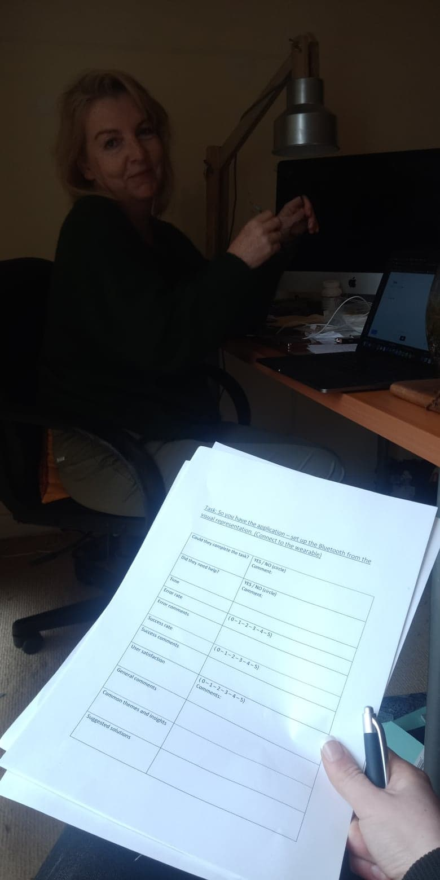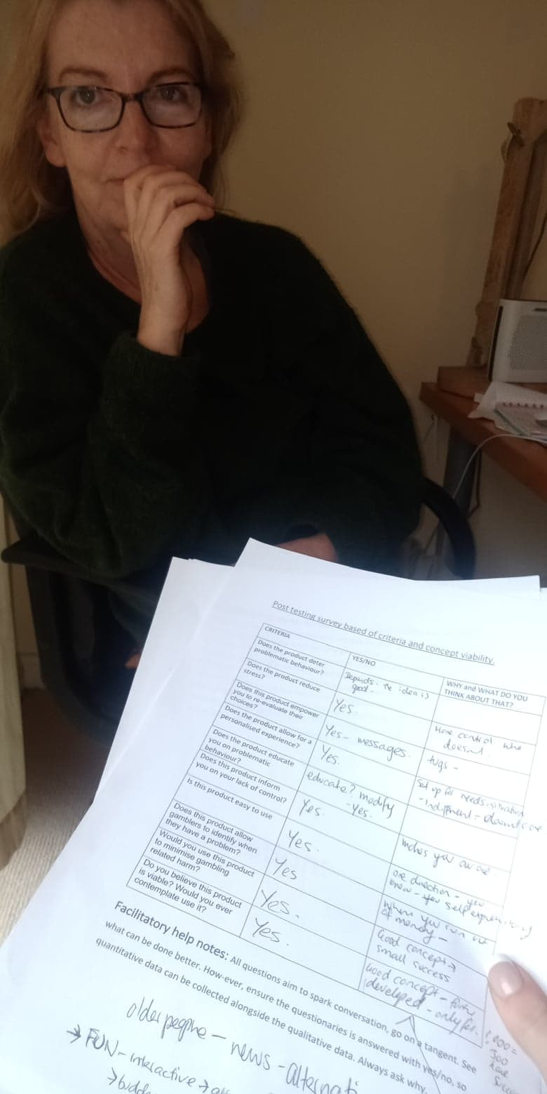

(Photos taken before and during survey because mock-up was on phone and I don’t have another phone to take photos – bitch aint rich).

Mental models – user understanding.

Conceptual model – designer designs – our conceptual model.

Visible – what we see.

Audible – what we hear

Tactile – What we touch and feel e.g keyboard.

Gustatory – What we taste

Olfactory – Smell

Affordance – knowledge that tells you how to use it. E.g. scissors – shape of handle shows u how to use them. (Perceived vs real – scissors are real. - digital artefacts mimic real affordances. e.g. sliders having shadows so they seem like they can be clicked and moved. – people need to be able to see how it works – signifiers are good at helping people figure it out.

Visibility – making functions visaible. – limits need to be more visible in our product.

Feedback – What has been done -

Constraints – decreasing options. – WE HAVE GOOD CONSTRAINTS ON THE MOCK UP CURRENTLY.

Mapping – Controls and their effect on the world.

Consistency –similar operations use similar elements to complete similar tasks.

Get me where?